SVM

Support vector machine is another well-known commonly used supervised machine learning algorithm which can be used for both classification and regression problems. SVM tries to find the best hyperplane which separates the data into groups which can used for classification or regression.

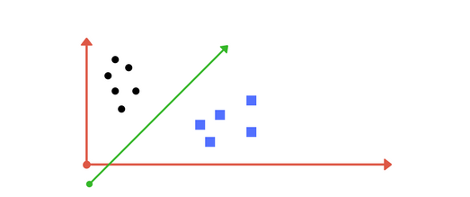

Consider the above graph with classes, circles and boxes. Since there are only 2 features, the separation these groups become easier and use a line to do so. But as the features increase, dimensionality also increases and uses hyperplane or set of hyperplanes to separate the classes. These lines are called as decision boundary. Anything that falls to one side of the line will be classified as circle, and other side as box.

How to decide Best hyperplane?

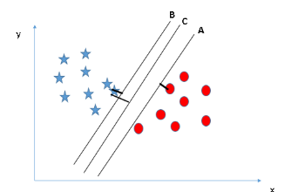

Margin width is the distance between the plane and the nearest data point. SVM tries to maximize the margin width to achieve the goal of choosing the right hyperplane. As shown in the image, line C is the best hyperplane as margin is high when compare to others.

Nonlinear data – The kernel Trick

Not every time data will be linear. Most of the times data will be non-linear and linear hyperplanes will fail to classify the data. To solve that problem SVM introduces a concept called Kernel trick.

